AGENDA
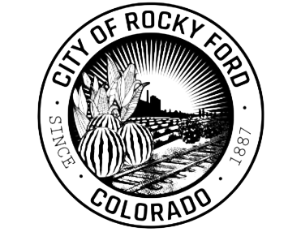
203 S Main Street
Rocky Ford, CO 81067

PH: 719.254.7414
FX: 719.254.7416
_______________

Stacey Milenski
Interim City Manager
_______________

Duane Gurulé
Mayor

Nicole Roberts
Ward I

Sherry Cordova
Ward I

Larry Herrera
Ward II

Nic Martinez
Ward II

Robert Barron
Ward III

Thomas Mullins
Ward III
_______________

City Clerk
719.254.7414, ext. 107

Police Chief
719.254.3344

Fire Chief
719.254.3322

Public Works
719.254.7414, ext. 105

Human Resources
719.254.7414, ext. 110

Parks & Recreation
719.254.7414, ext. 106

SPECIAL Meeting - Rocky Ford City Council
Monday, April 29, 2024 at 10:00 a.m.
City Hall Council Chambers
or ZOOM

REMOTE PARTICIPATION
A Zoom link is made available, however, the City does not and cannot guarantee Internet connection or online broadcasting. Remote attendance is at the risk of the attendee as the public meeting will continue in person regardless of the City’s broadcasting capability.

Join Zoom Meeting by Computer: https://us.06web.zoom.us/j/98350467857 – Meeting ID: 983 5046 7857

- Call meeting to order

- Roll Call

- NEW BUSINESS
3.1 Application for Special Event Permit. Application filed on 4/15/2024. Liquor event posted at City Hall and at Arkansas Valley Fairgrounds on 4/15/2024 (must be posted 10 days prior to Council review) – Small Town Project – Arkansas Valley Fairgrounds, 800 North 9th Street, Rocky Ford, CO for Arkansas Valley Cinco de Mayo Fiesta -

- Adjournment

MEETING CALLED BY: Mayor and City Clerk

cityofrockyford.colorado.gov

