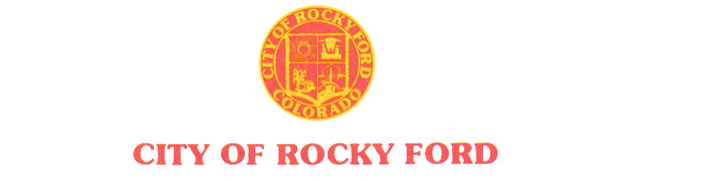
203 South Main * Rocky Ford, CO 81067 * (719) 254-7414 * Fax (719) 254-7416 ______________________________________________________________________

AGENDA
Regular City Council Meeting
Tuesday, July 9, 2019

- The order and times of agenda items are approximate and intended as a guideline for the City Council –

Item # | Worksession – 6:00 PM
1. | Chamber Agreement (Gobin Building)
 | Recess
 | Regular Council Session – 7:00 PM
1. | Call to Order
2. | Roll Call
3. | Pledge of Allegiance
4. | Approval of Minutes from June 26, 2019 Regular Meeting
5. | Citizen Participation – 3-minute time limit  Citizen participation is for items not otherwise on the agenda
6. | Approval of Agenda and Consent Agenda
 | Staff Reports
 | Mayor City Council Reports/updates
Citizen Participation – 3 minute time limit
- Citizen participation is for items not otherwise on the agenda
 | - Items for Consideration at Future Meeting
 | Departmental Reports; Gobin’s agreement (letter sent); School board work session (JR look into); Review City Code (work sessions); City Property sale; Employee Benefits;
 | Adjournment

