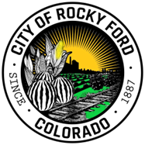CITY OF ROCKY FORD – CITY COUNCIL MEETING

December 24, 2024

MEETING VACATED

